

**CSE PROJECT 2022**

**Subject:- Computer Science**

**Subject Code: - CSC291**

**Topic: - Game Development**

BY: -

arya kumar johary (12021002026028)

ritam halder (12021002026046)

abhay prasad (12021002026024)

# **HISTORY OF PYTHON:**

Python is a widely used general-purpose, high-level programming language. It was initially designed by Guido van Rossum in 1991 and developed by Python Software Foundation. It was mainly developed for emphasis on code readability, and its syntax allows programmers to express concepts in fewer lines of code.

In the late 1980s, history was about to be written. It was that time when working on Python started. Soon after that, Guido Van Rossum began doing its application-based work in December of 1989 by at Centrum Wiskunde & Informatica (CWI) which is situated in Netherlands. It was started firstly as a hobby project because he was looking for an interesting project to keep him occupied during Christmas. The programming language which Python is said to have succeeded is ABC Programming Language, which had the interfacing with the Amoeba Operating System and had the feature of exception handling.

The language was finally released in 1991. When it was released, it used a lot fewer codes to express the concepts, when we compare it with Java, C++ & C. Its design philosophy was quite good too. Its main objective is to provide code readability and advanced developer productivity. When it was released, it had more than enough capability to provide classes with inheritance, several core data type exception handling and functions.

## **introduction of project:**

Well, you all have heard about the term **Game**. A Game can be defined as an activity enrolled for amusement as a prepared form of play that basically undertakes for enjoyment and/or as an educational tool.

According to **Game Theory**, which is a study of mathematical models, while playing a game, there is either a win or a loss or a tie among the candidates participating in the game and that is based on the actions performed or the decisions taken during the gameplay.

**SOFTWARES USED IN THE PROJECT:**

Unity Engine, Visual Studio 2019.

**HARDWARE OF SYSTEM USED IN THIS PROJECT:**

CPU: - Intel Core i5 11400H

GPU: - Nvidia RTX 3050 (4GB VRAM)

RAM: - 8GB

STORAGE: - 512GB SSD

**REQUIRED LIBRARIES:**

Unity Library, Unity Asset Library, Visual Studio 2019 C# Library.

**SCREENSHOTS:**

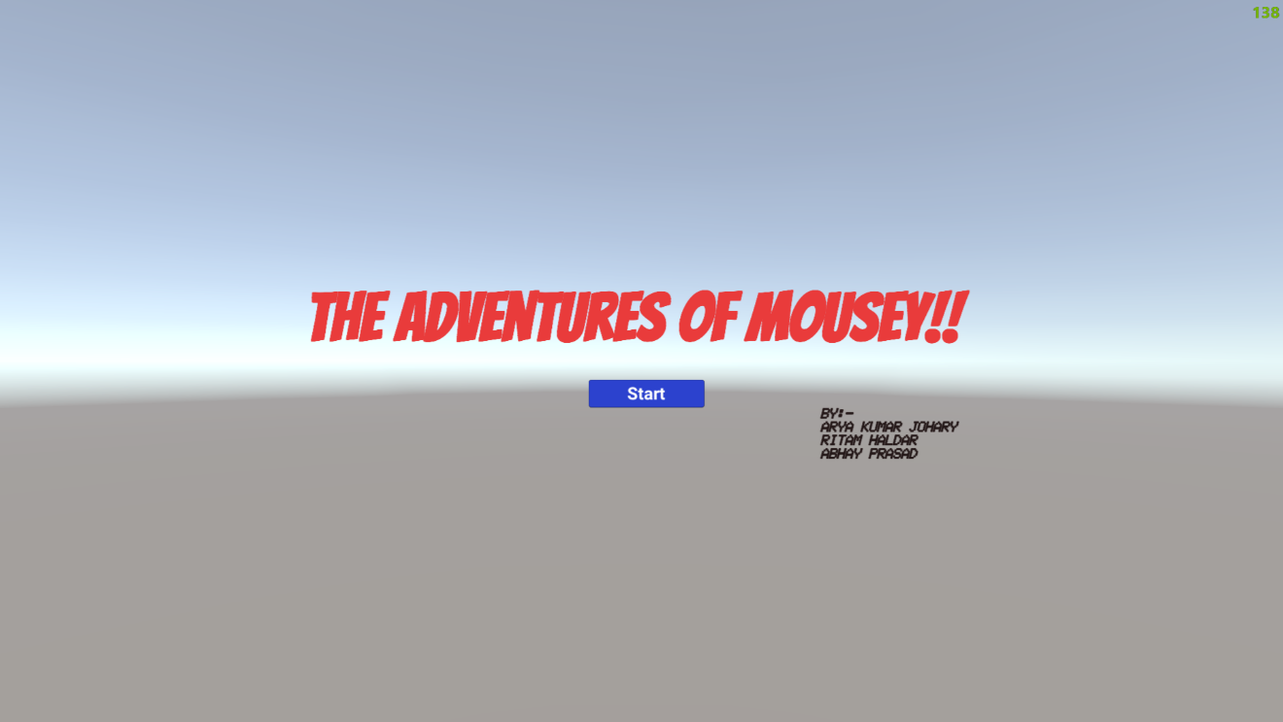

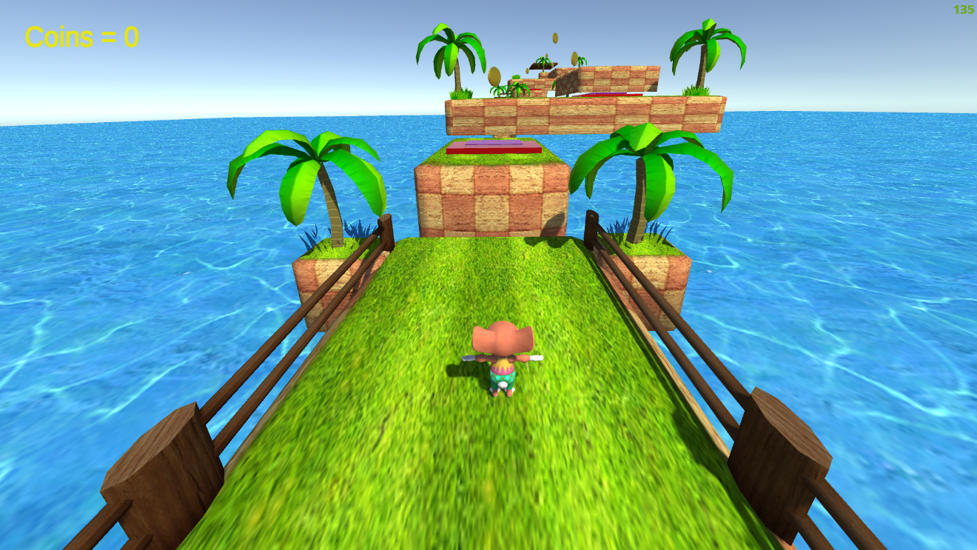

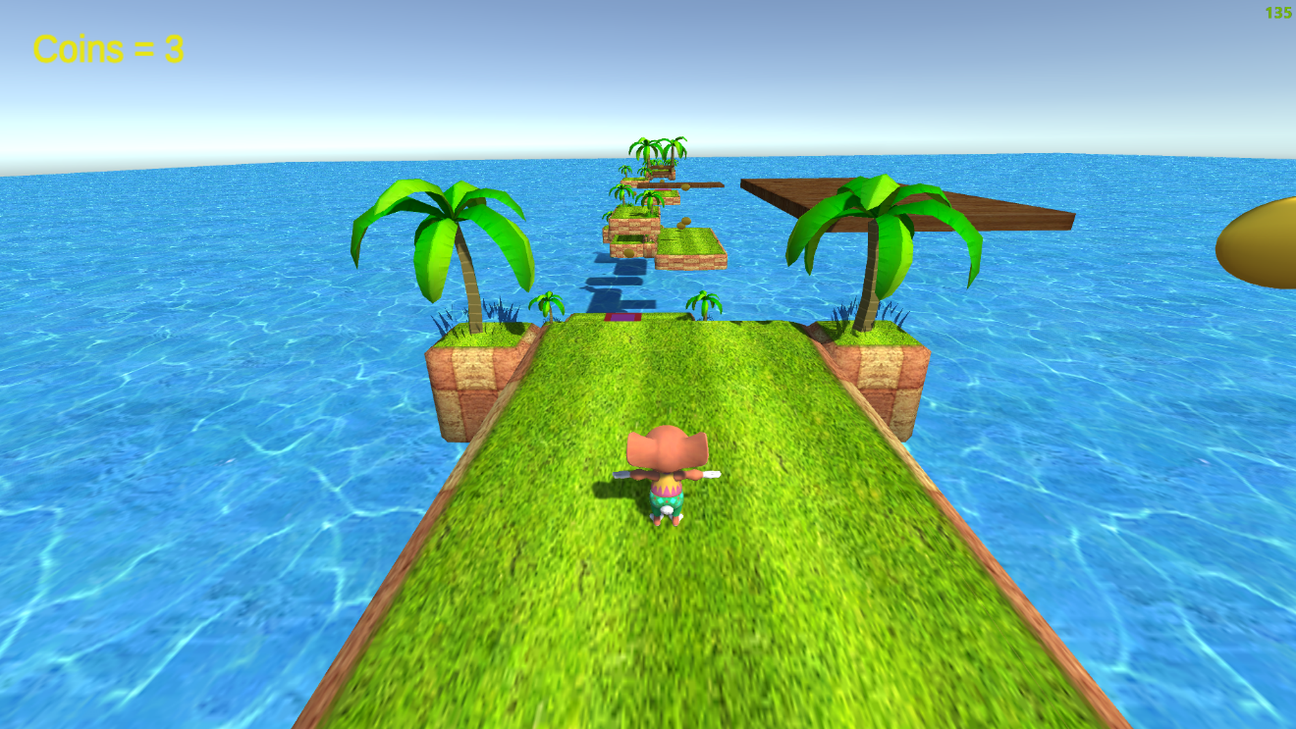

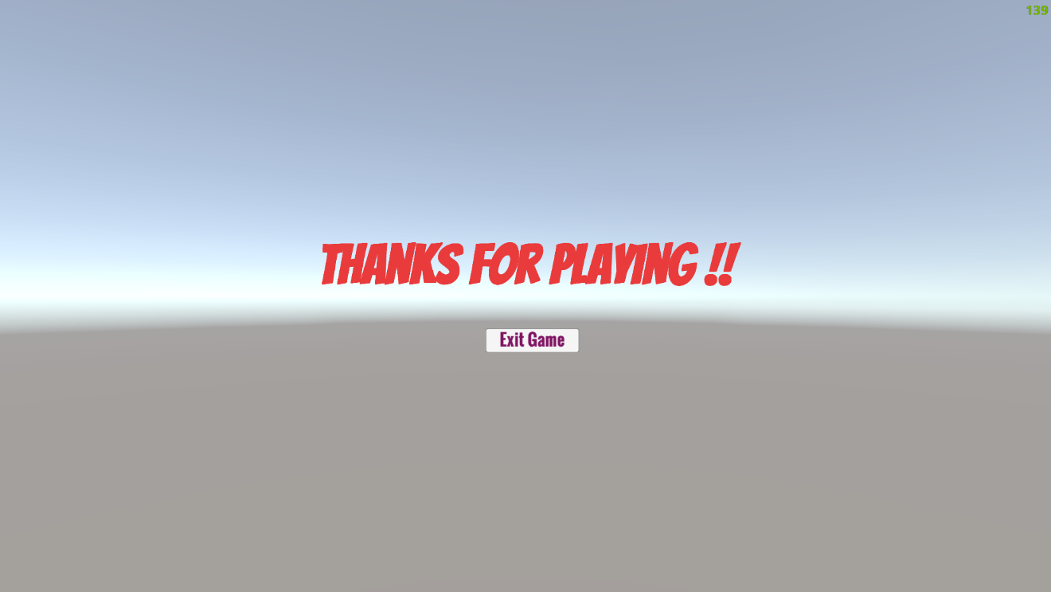

**RELATED PROJECTS:**

**1. Client-server game:**By working on this game development project, you will learn to develop a game using a client-server network. This type of game helps to avoid problems like disconnection due to poor internet. Mini militia, Asphalt 8 are some examples of client-server games.

**2. Rock, paper, scissor game using python:**Everyone of us might have played this game during our childhood. In this game development project, you will use the python programming language to develop this game.

**3. Sudoku game:**Playing Sudoku will help you to improve your IQ. Developing a simple sudoku game is one of the best ways to start with game development. In this game development project, you will learn to develop a sudoku puzzle that contains a 9x9 grid and 3x3 occupied with numbers.

**4. Tank fight game:**In this game development project, you will develop a multiplayer game where two players will be placed on top of a mountain and equipped with a tank. They will shoot each other and the first one falls from the cliff loses the game.

**5. Tetris game:**Tetris is one of the basic games and also the best choice to learn game development. In this game, you will use the arrow keys to control the movement of the elements.

**6. 2D racing game:**In this game development project, you will develop a 2D car racing game using python, where two cars will be going in a starting line and the player has to change the gears according to the RPM to win the game.

**7. Pinball game:**It is one of the interesting arcade games of all time. You will use the python programming language with pygame library to develop this game. By working on this game development project, you will use some physics concepts to calculate the projection of the ball.

**ORIGIN OF OUR IDEA OF THIS PROJECT:**

LinkedIn, YouTube, Unity.

**FUTURE PLANS WITH THIS PROJECT:**

Our future plan with this project is to refine it to the very top level and improve our coding and designing skills on our way.